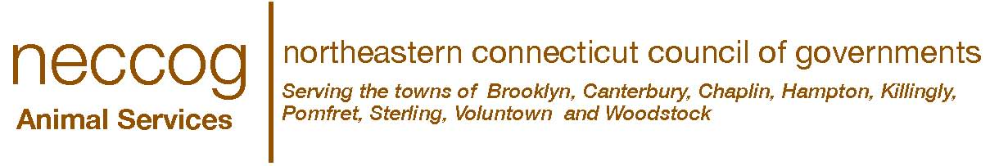

Cat Adoption Questionnaire
Email: animalcontrol@neccog.org
Facebook Page: NECCOG Animal Services

Name__________________________________ Email_______________________________
Address______________________________________________________________________
City/State_______________________________ Zip_________________________________
Primary Phone___________________________ Alternate Phone_______________________
**Thank you for the considering the adoption of a shelter animal! Before you decide to adopt a pet please consider the time, effort, and funds (estimated at $1000or more annually for food, supplies, vaccinations, and veterinary care) necessary to properly maintain an animal. Responsible pet ownership requires a commitment to provide care and companionship for the life of the animal. The decision to adopt is an important one. In order to insure that you and your pet will be happy for years to come, we need to take time to discuss the animal’s individual needs and personality traits. Please take a few moments to carefully read and complete this application.**
1. Name of cat that you are interested in (if applicable) ________________________
2. Do you currently live in a House___ Apartment___ Condo___ Other___?
3. Do you currently Own___ Rent___ Lease the residence where you live___
4. How long have you lived at your current resident? __________________________
5. If you are not the property owner, NECCOG Animal Services will verify your residences current pet policy.
Landlord’s Name_________________________ Phone Number________________________
6. How many adults live in your home? ___ How many children ___ Ages_________________
7. Does anyone in your household have allergies? Yes___ No___
8. Who will be primarily responsible for the care of this cat? _____________________________
9. Is this cat a gift? Yes___ No___
10. Do you have other pets: Are their vaccinations current? Yes___ No___
11. I f dogs, are they currently licensed? Yes ___ No___
12. Do you have a regular veterinarian? Yes ___ No ___ Name __________________________
13. Under what circumstances would you not keep this cat? _______________________________
14. Please list all of the pets you have had in the last 10 years including current pets, and those you no longer own.
Name | Species | Breed | Age | Sex | Altered | Owned how long? | What happened to him or her?

15. The noise/activity level in my home is usually: High ___ Medium ___ Low ___
16. I would enjoy brushing or grooming my cat: Rarely ___ Occasionally ___ Daily ___ Weekly ___ Monthly ___
17. My ideal cat would: ____________________________________________________________
18. Bad cat habits that I just can’t tolerate are: _________________________________________
19. Will this cat be: Inside_____ Outside_____ Inside/Outside______?
20. Would you declaw a cat? Yes___ No____
** I certify that the above information is true and correct to the best of my knowledge. I also acknowledge falsification of the above can result in my being denied adoption of an animal or, if an animal has been adopted to me, the returned of that animal to NECCOG Animal Shelter. **

Signed _______________________________________ Date: ________________________

